Task 1: Delivery Reward Function Build a Python function that calculates and returns a reward score for a food delivery agent based on the outcome of a single delivery action. Define a function calculate_reward(delivery_time, is_on_time, customer_rating) that accepts three parameters. Award +10 points if is_on_time is True; deduct -5 points if it is False. Add the customer_rating (integer 1–5) directly to the reward total. Print the final reward with a descriptive message and test the function with at least three different input combinations showing different outcomes.

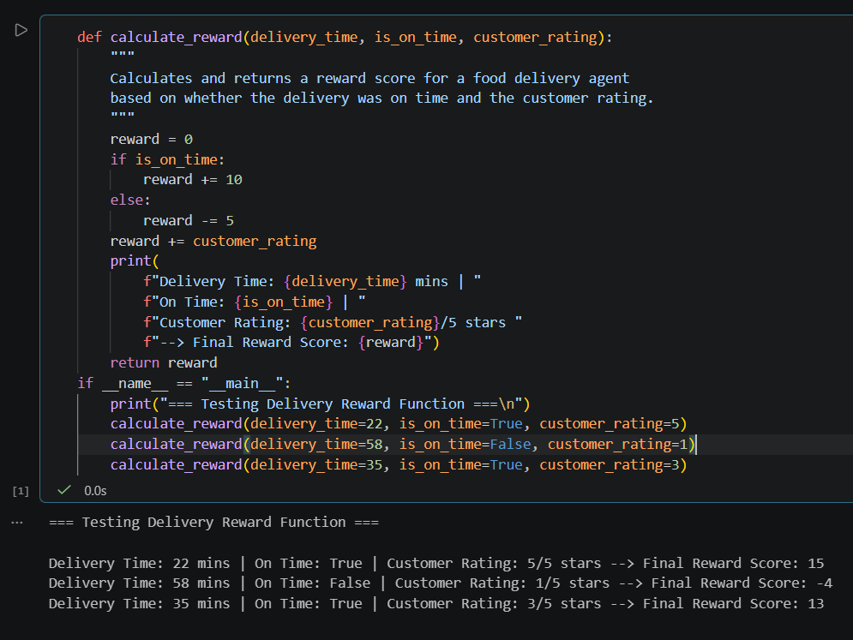

===========================================================================

Task 2: Agent State Tracker Build a dictionary-based Python program that tracks a delivery agent's state across multiple time steps, simulating the state component of an RL environment. Create a dictionary representing the agent's state with keys: location (string), orders_delivered (integer), total_reward (float), and is_available (boolean). Define a function update_state(state, new_location, reward_earned) that updates the agent's location, increments orders_delivered by 1, and adds reward_earned to total_reward. Simulate at least four state transitions by calling update_state with different locations and reward values. After each update, print the complete current state in a clear, readable format.

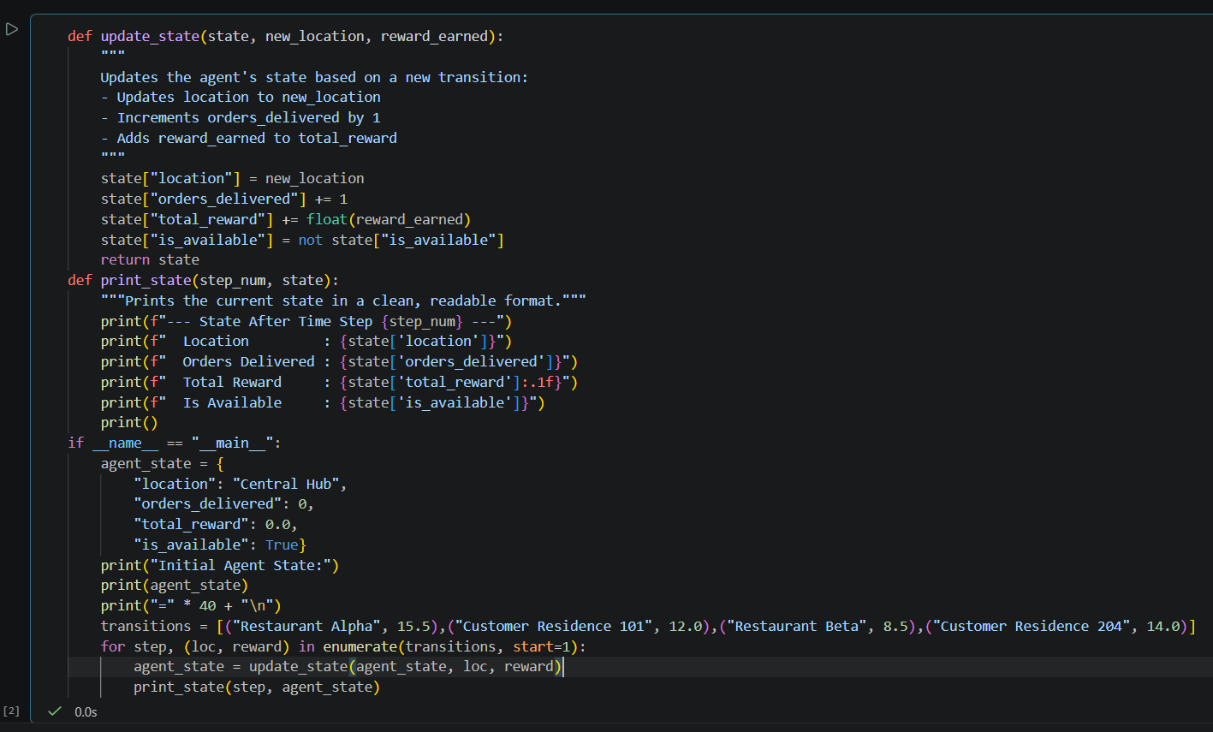

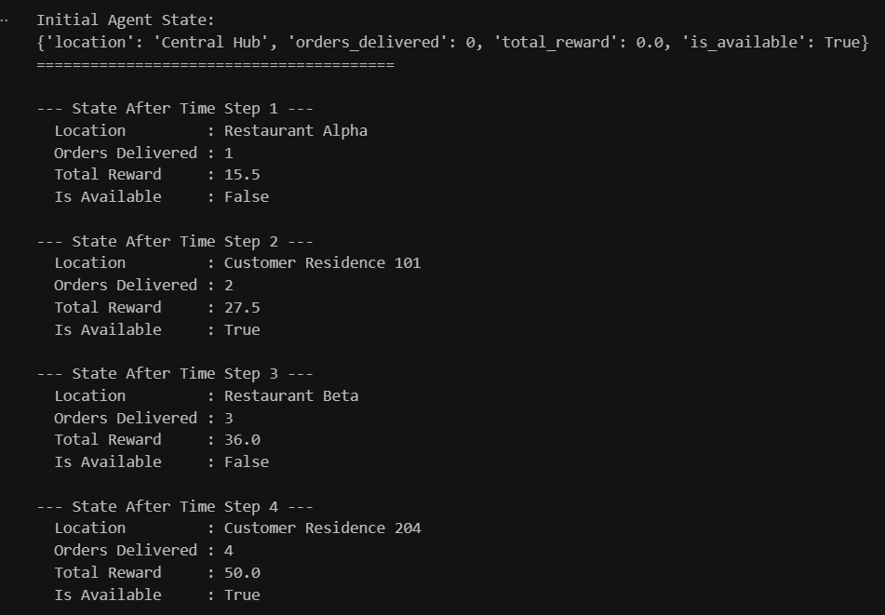

===========================================================================

Task 3: Action-Reward Episode Logger Build a Python program that simulates one episode of a delivery RL agent executing a fixed sequence of actions and logs the cumulative reward at every step. Define a list of possible actions: ['accept_order', 'reject_order', 'request_directions', 'mark_delivered']. Assign a fixed reward to each action using a dictionary: accept_order = +2, reject_order = -1, request_directions = 0, mark_delivered = +10. Simulate an episode by iterating through a predefined sequence of at least six actions, computing and accumulating the reward at each step. Print each step showing the action taken, the reward received at that step, and the running cumulative reward. Print the total episode reward at the end.

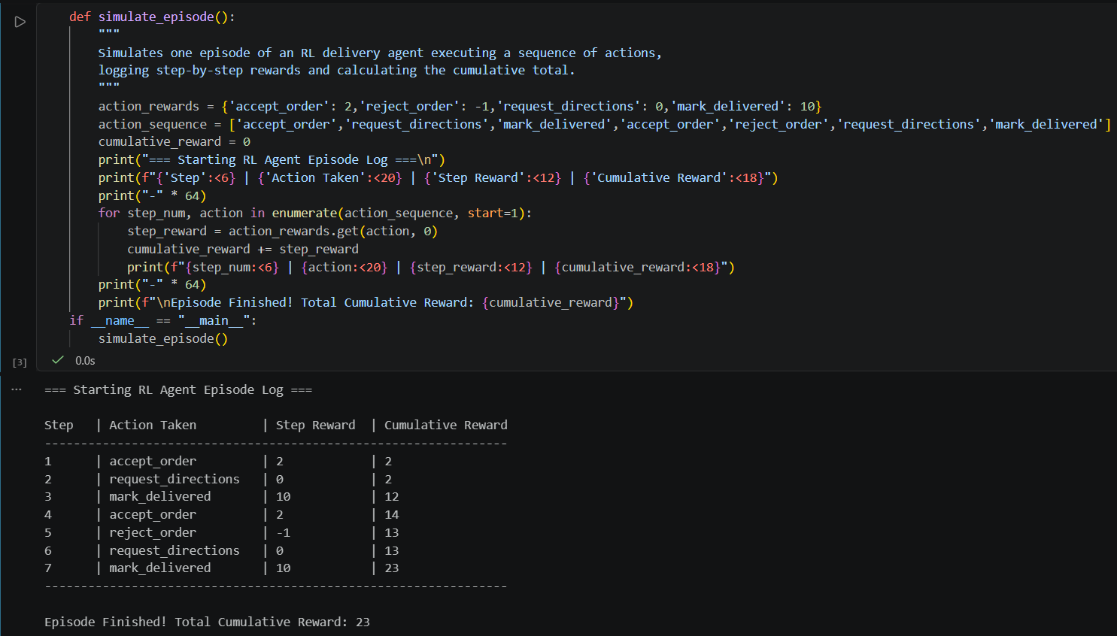

Task 4: Simple RL Environment Simulator Build a console-based Python simulation that models the full agent-environment interaction loop for a delivery scenario, combining state tracking, action selection, and reward accumulation into a single class-based program. Define a DeliveryEnvironment class with attributes: current_state (a dictionary with at least location and pending_orders), total_reward, and step_count. Implement a step(action) method that updates the state based on the action taken, computes and returns a reward value, and prints the new state and reward after each step. Define at least three distinct actions with different state-transition effects and reward values (e.g. deliver_order, wait, navigate_to_zone). Run a loop that executes a predefined sequence of five or more actions, prints the result of each step, and displays the final total reward and total step count at the end.

